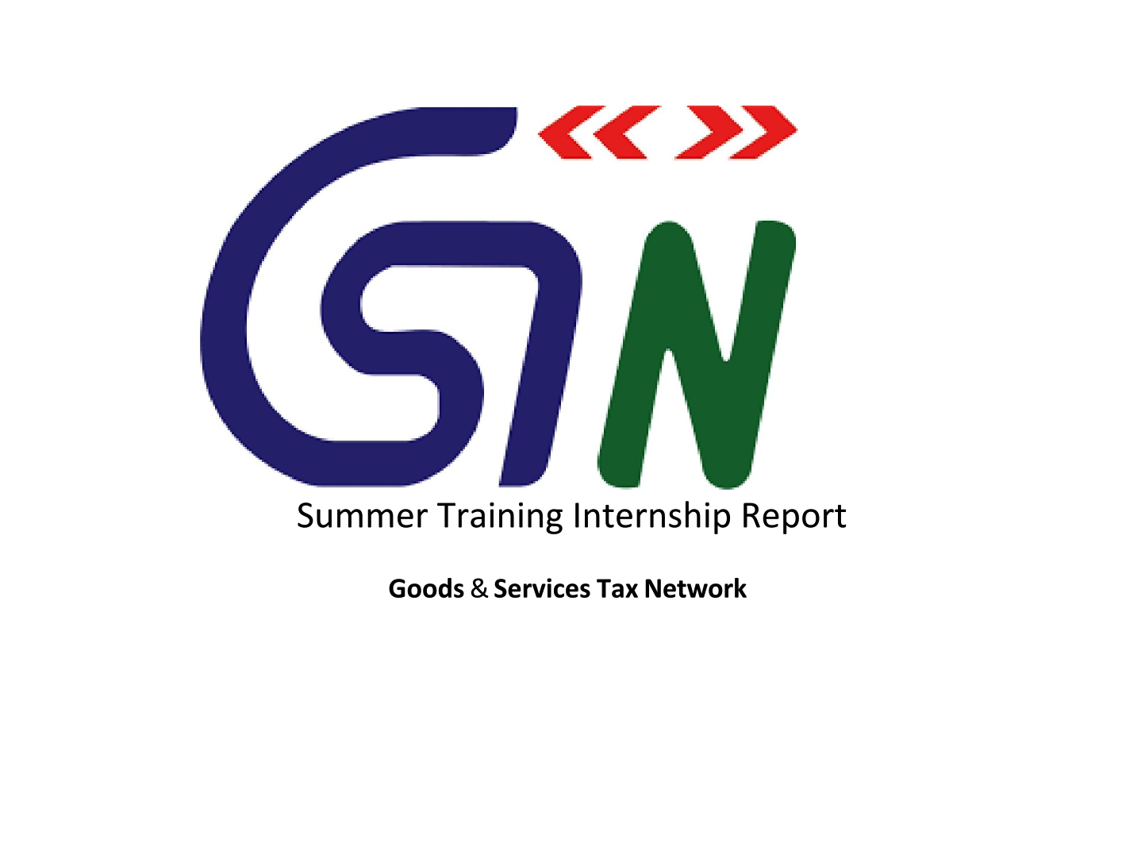

Submitted by
Yagya Mohan
Data Science and Machine Learning Intern
CERTIFICATE FOR INTERNSHIP
TO WHOMSOEVER IT MAY CONCERN
This is to certify you that Ms. Yagya Mohan, student of Vellore Institute of Technology, Vellore has successfully completed her internship from 28th May 2024 to 9th July 2024 at Goods and Services Tax Network (GSTN).
During the internship Ms. Yagya Mohan has closely worked as part of BIFA (Business Intelligence & Fraud Analytics) as a Data Science and Machine Learning Intern.
She demonstrated good creative skills and also was a quick learner throughout the program. Her creative ideas, programming and data science skills were useful for us in our projects.
We wish her all the best for her future endeavors.
ISSUED DATED – 9th July 2024

Mr. Bharat Jha
(Assistant Vice President)

Abstract
This internship report presents an overview of my experience and the knowledge gained during my tenure as a Data Science and Machine Learning Intern at Goods and Service Tax Network (GSTN). Over the course of the internship, I actively contributed to a significant project: "Fake Dealer Prediction" .This report details the objectives, methodologies, challenges, and outcomes of these projects, providing insights into the practical skills and technological proficiencies I developed.

Introduction
My internship at Goods and Services Tax Network (GSTN) provided me the much-needed exposure to delve deeper into the world of Data Science and Machine Learning via real-world projects like the “Fake Dealer Prediction” project. I was provided with an encrypted data set on which I had applied a model to distinguish fraudulent dealers from the non-fraudulent ones. Hands on application of the theoretical machine learning algorithms helped me to hone my Machine Learning skills.
I also became familiarized with the workings of a large internal organizations, the adherence to deadlines, data security and privacy and the importance of dedication and hardwork.

Project 1: Fake Dealer Prediction

Objective :

The " Fake Dealer Prediction " project aimed to develop a predictive model that could accurately distinguish between fraudulent and non-fraudulent dealers (binary classification)

Methodology:

Data Collection
Data Source: The dataset was provided by the organization and is encrypted for security. It comprised of 21 columns (including 1 ID column) and 106485 rows.

Data Preprocessing
- Removal of Irrelevant Data:
  - Removed records with excessive missing values that could not be reasonably imputed without introducing bias.
  - Applied machine learning models to predict and fill in missing values based on related features when simple imputation was insufficient.

Feature Selection
- Utilized feature importance scores from preliminary models to refine the feature set.

Model Training and Evaluation
- Explored various machine learning algorithms, including:
  - Random Forests: Used all features for model training.
  - Logistic Regression: Used all features for model training.
  - Support Vector Machine (SVM): Applied feature selection to reduce the dimensionality before training.
- Evaluated the performance of each model using the following metrics to determine the most effective approach:
  - F1 Score
  - Precision, Accuracy and Recall
  - Confusion Matrix

Observation

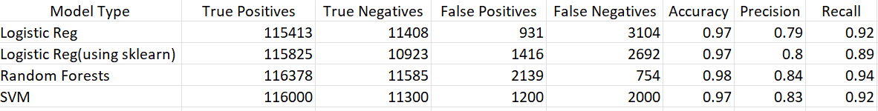

Challenges and Outcomes
- Challenge: Decrypting and Preprocessing Large, Encrypted Datasets
Outcome: Successfully decrypted and preprocessed the large encrypted dataset provided by the organization for the Fake Dealer prediction project, including imputation techniques to handle missing data and ensure accurate data preparation for model training.
- Challenge: Selecting the Most Suitable Machine Learning Algorithm
Outcome: Conducted rigorous experimentation and evaluation of three different machine learning algorithms for the Fake Dealer prediction project. Presented a comparison metrics table to analyze and compare their performance, helping to guide the selection of the most suitable algorithms for accurate predictions.
- Challenge: Maintaining Data Security and User Privacy
Outcome: Implemented secure data handling practices, including encryption and secure communication protocols, to protect user data. Ensured compliance with relevant data protection regulations to maintain user trust and confidentiality.

Conclusion
My internship at GSTN has been a transformative experience, allowing me to apply and expand my knowledge in data science and machine learning. Working on the “Fake Dealer Prediction” project provided practical insights into the intricacies of data and its management and molding into a model to yield the desired results.
These projects have not only honed my technical skills but also enhanced my problem-solving abilities and understanding of the broader context of data science and machine learning. The hands-on experience and the professional exposure I gained during this internship have significantly prepared me for future challenges in the field of Data Science and Machine Learning.

